**Analysis Document for US98:**

Below are the analysis details done as per the user story.

Have analyzed all the fields from which API they are getting populated, accordingly we can calculate the load on landing page.

As per below analysis, most of the fields are getting populated from Siebel so there is very less impact of the data that is getting loaded on landing page, hence creating partial view for Part Details wont be required as it wont impact on the performance of landing page.

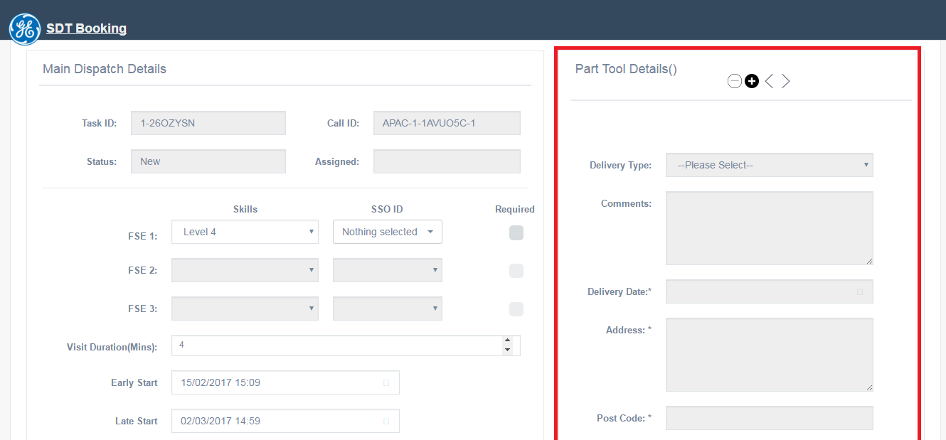

In the above picture, the area marked in red is getting populated from Siebel, even in that Delivery Type values are hard coded and Countries List is getting populated from XML file. SO this is not have impact in loading of page.

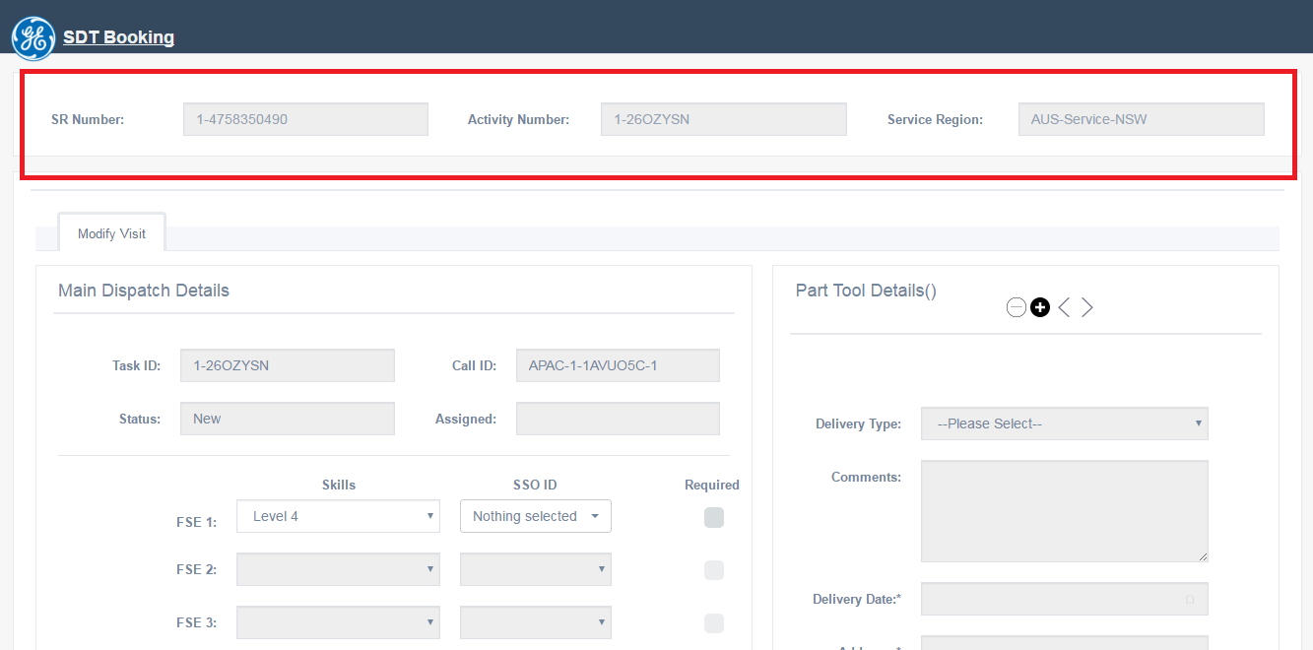

SR Number, Activity Number and Service Region are getting populated from Siebel.

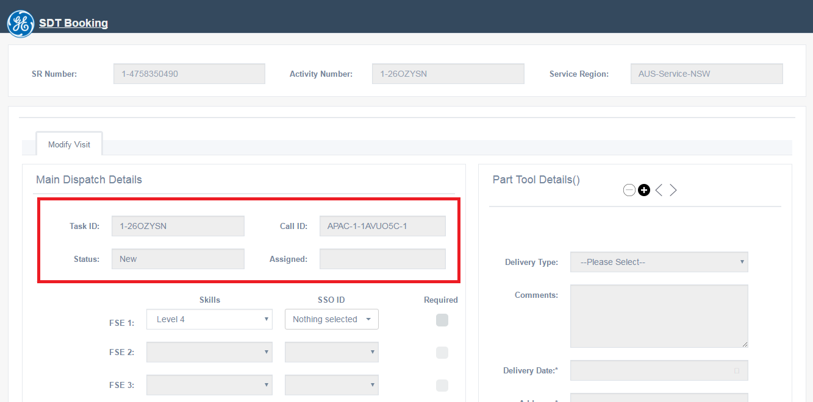

Task ID. Call ID, Status and Assigned are getting populated from Click

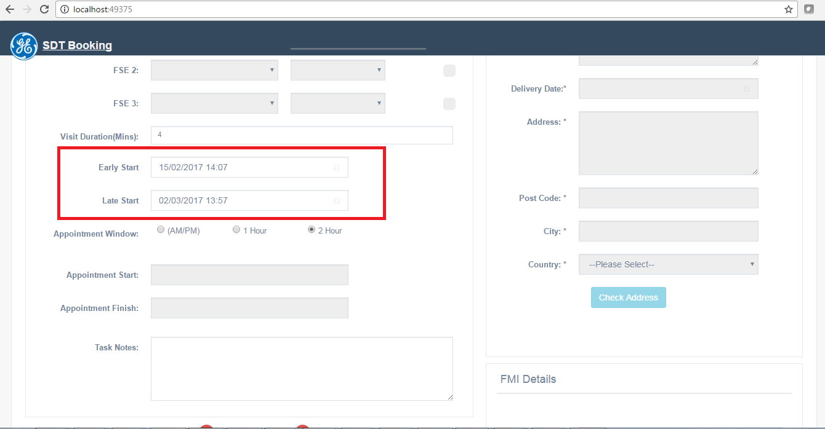

Early Start and Late Start values are dependent on Siebel and on further calculation (on the basis of SR Type) in SDT the values are displayed.

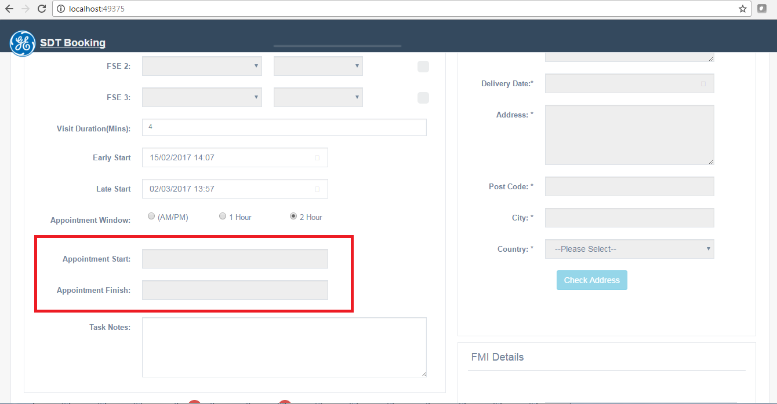

Appointment Start and Appointment Finish values are getting populated from Click.

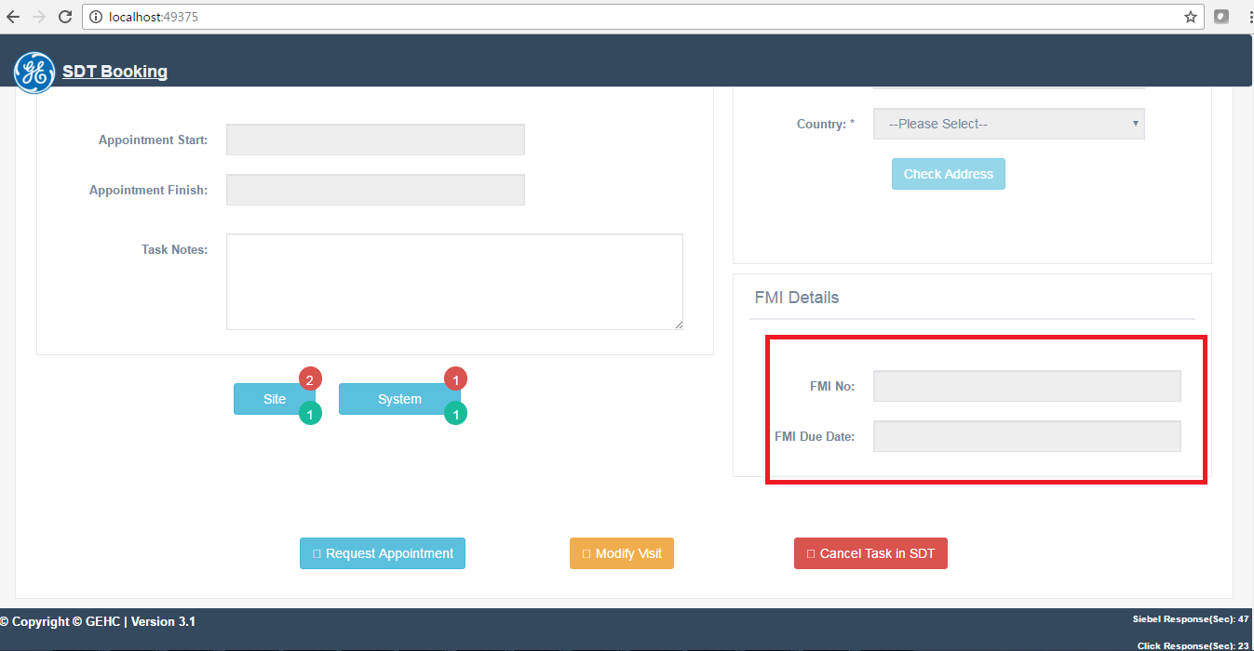

FMI No and FMI Due Date are getting populated from Siebel.

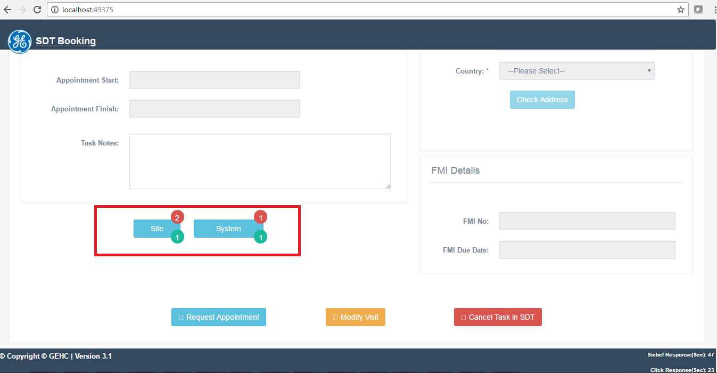

Site and System data are getting populated from Click.